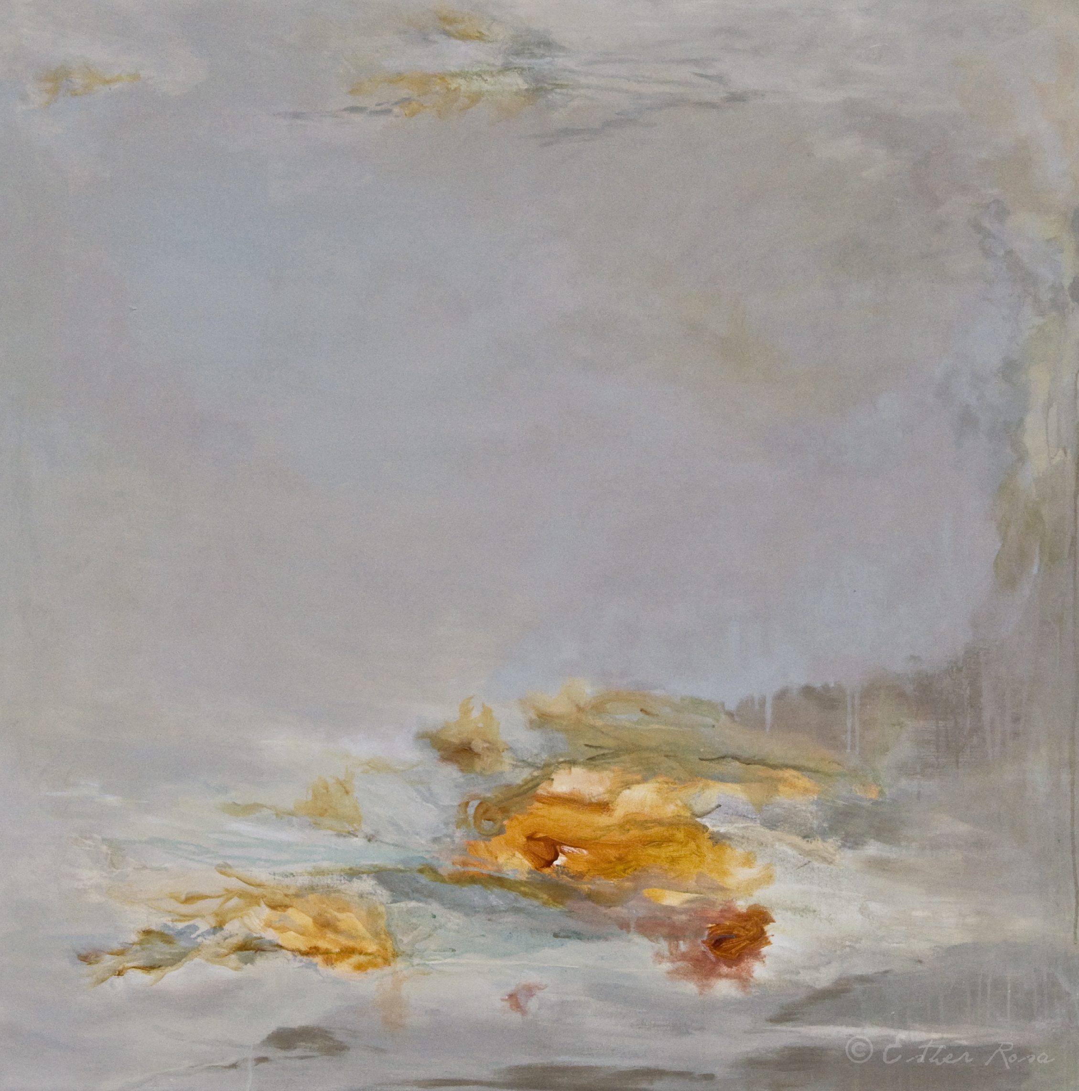
IMMEDIATE PRESS RELEASE
ESTHER ROSA | BREATHING, March 2nd, 2013 to March 23rd, 2013

S ARTSPACE GALLERY is pleased to present the first solo show of the Spanish artist, Esther Rosa, including natural processing paintings as well as organic installations.
Esther’s work is a continual dialogue between her past in Madrid and her present in New York. Through her work, she is able to communicate a visual representation of her thoughts and feelings. “Breathing”, with its roots, elegance, serenity, joy, life and expression is all of this. ”Breathing” represents her new identity. It is a new step in her life. “Breathing” was born as a solid body of work; organic forms inspire the process of layering, pouring and dripping paint in the canvas that flow in between the harmonic palette and the surface; when she works with paper, coffee filters, wood and beeswax, organic elements help her to reborn, awake, to breath, to become alive... The process includes conscious and accidental methods and is gradually defined by discipline and persistence. Organic forms come naturally and create harmonious fluidity throughout the piece. Surface variances pull the medium into multiple directions. She works in numerous layers and makes conscious decisions about leaving parts visible, obscuring or covering up areas, some times using sand, paper or mediums. Some times metallic colors are incorporated in her paintings because they bring richness, luminosity and a touch of sophistication. The chemical reaction of combining certain mediums or metallic color with other pigments are unpredictable and can manipulate the colors, oxidation and how a piece turns out; It becomes a process of discovery which influences the way she will approach future works. The complexity of paint application and layering techniques offer the viewer a tangible surface of the visual language.
The process for installations and sculptures are defined by the choice of natural materials to work with: coffee filters, coffee, tea, wood, beeswax.... she will stain the paper using coffee and tea., conscious and accidental methods guide the artist to shape them. The final work evokes a dreamful nature!

